British Motorcycle Association of Colorado
We have started a new series of Tech Tips at our monthly meetings. For those of you who were not at the meeting, here is an outline of the information presented. We are also looking for members who want to do a “Tech Tip” at upcoming meetings. Contact Frank Puckett at reyefledoc@msn.com to get on the schedule.

  - Tech Tip #1 Sanding with a Glass “Surface Plate” by Frank Puckett
Many times we need to sand and true a surface for a gasket face, or take the burrs off of a nut or washer. I like to use a piece of sandpaper glued to plate glass to create a very flat sanding plate. Following is how to set up a sanding surface plate:
- I like to use a piece of glass that is at least ¼ “ thick, and is slightly larger than a 9 x 11 sheet of sandpaper. Your glass supplier can get scrap for you and sand the edges for safety.
I have not used tempered glass, I am just careful with regular glass and keep it at least ¼” thick for flatness and durability.
- Have a spray can of adhesive, I have used Elmer’s Spray Adhesive with good results.
- Spray your glass lightly with the adhesive and let it dry for 2-3 minutes or as directed by the product you are using. I just spray the glass only, to create light adhesion so the paper can be removed after it wears out.
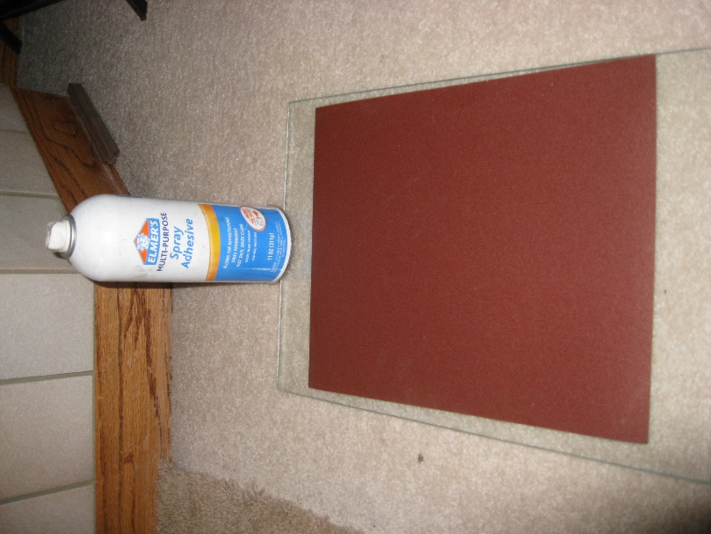
- Position your sandpaper on the glass, keeping it flat and waiting few minutes for adhesion. Pay special attention to keeping the edges glued so you don’t catch them when sanding.

Now for some general notes. The most common grits of sandpaper I use are 180, for more serious metal removal, and 320 for truing gasket surfaces. I am a big fan of SAIT sandpaper that is distributed by United Abrasives. The Ultimate Performance Aluminum Oxide with paper backing works better than anything I have ever used. I use the AW-C and AW-D designations. It is available on order from Colorado Compressed Gas in Colorado Springs, and buying it on the internet does not appear easy. I think United Abrasives sells a lot through salesmen and other outlets. CCG told me they could get what I wanted through them. I got my original supply through a salesman that has since retired. United Abrasives also make round cartridge rolls that run on a mandrel in a drill or die grinder that are useful for sanding inside tubes, etc.
If you are truing a lot of engine cases or larger primary covers, a larger piece of glass where you could glue two sheets of sandpaper side-by-side might be very useful.
Another trick I use a lot is to make a sanding stick by gluing a piece of sandpaper to a piece of wood with a handle. Also various size dowels with sandpaper glued to them are very handy in smoothing or enlarging a hole.
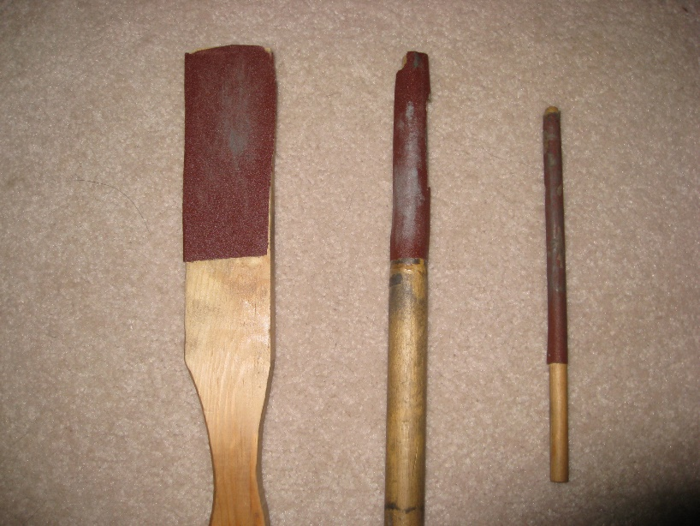

Below is a picture of me truing the rocker box side of a Truimph head. The next picture shows where the low spot is, so some more sanding will be required.
I use the sandpaper dry, and then either wash the sandpaper when it gets full of dust, or blow it off with compressed air. This sandpaper cleans off well either way and will last a surprisingly long time.

