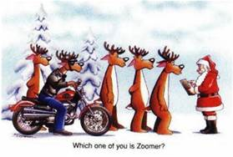

Merry Christmas
from the
British Motorcycle Association of Colorado

And here is hoping you have a zooming New Year!
See you at the January 2nd Meeting!

