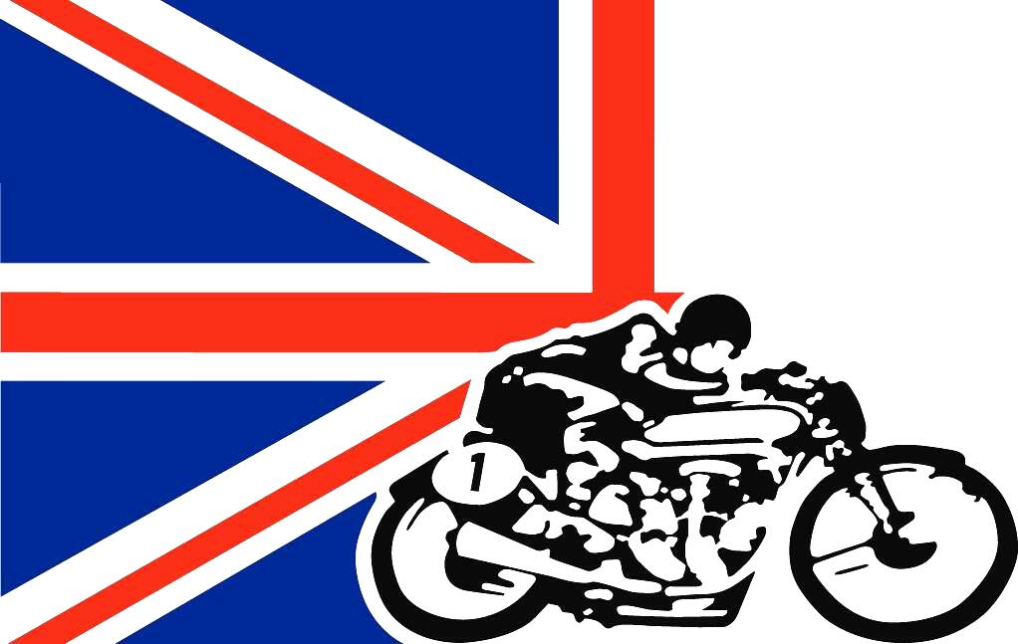

British Motorcycle Association of Colorado
President’s Message, 2016

Well, our Christmas party is coming up fast, Saturday December 3rd. If you haven’t signed up to come, you need to do it now!! It is time to reflect on all that has happened this last year, and encourage everyone to come to the party and cap off this busy BMAC year. And make a resolution to enjoy and get involved in your club for 2017.
Our members have made our monthly meetings topnotch, with great camaraderie, special presentations, and even some education. We see between 30 and 35 members at each meeting, which makes for great visiting and sharing. Following is some recaps of meetings for those who haven’t been to many of them. Make an effort to come to our meetings if you haven’t lately, we will try to make it worth your while!
In January, we heralded our enhanced website, www.bmacinc.com. Jim LeFebvre was a leader on this, with the help of his friend, Mo Hall. They took our website up another notch after John Stoner’s development the year before. Thanks to all three for making our website more visible and user friendly. Our meeting included pictures from my visit to the World of Speed Museum near Portland.
February’s meeting was highlighted with Helene Kafka’s slide show on motorcycling through the Himalayas, certainly a great adventure! We also learned about fender replacement from Jim LeFebvre. Robin Robbins took over the treasurer duties from John Schiebeler, and she is promoting our stock of BMAC swag. John took a welcome break from the treasurer duties after some 20+ years!
In March we brought the members up to speed on the differences between Triumph pre-unit and unit engines with the help of George Nachtsheim. It was great to have both types of engines on display. Dana Robbins also did a Tech Time on how to drill your vintage disc brake to make it look cool!
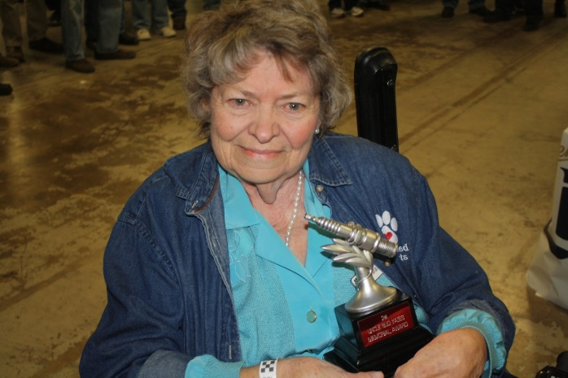
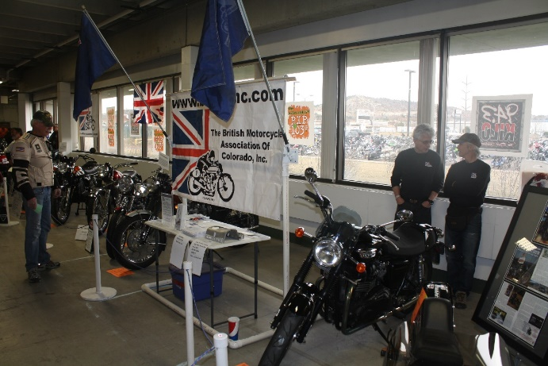
March is also the month of the Colorado Springs Motorcycle Super Show, and BMAC went all out this year with exhibits of Norton, Triumph, Velocette, Focesi, and Matchless motorcycles. Our display was the best of the show, in my opinion, and gave a nice alternative to the Harley crowd. Lots of awards were won, but Barb Manka received a special award for her long-term dedication to the motorcycle community.

Our meeting in April had a special presentation by Ivan Anthony on synthetic oils and how they can help your vintage bike last longer. A spirited discussion about oil followed, as it is always an interesting subject. We also went to school on chain and sprocket maintenance by Keith Branham and polishing your spokes by Dana Robbins.
In May our meeting was hosted by Pikes Peak Motorsports at their great facility. Roger Newman from Taint Paint told us about the ins and outs of powder coating. We then had John Stoner lead us in the annual skills competition in the parking lot. No cones were harmed in this endeavor.
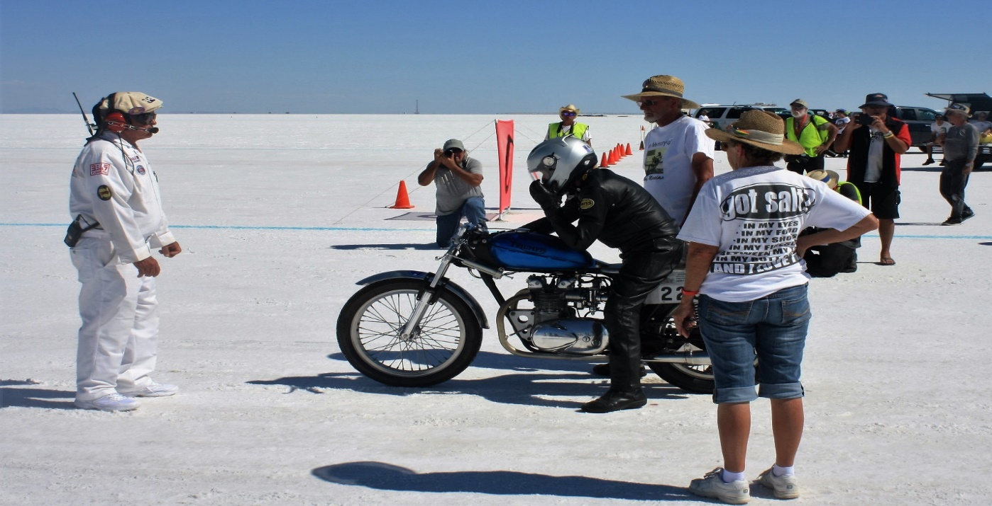
A number of club members visited the David Uhl Studio in May, and at our June meeting Dennis Oberwetter did a great slide show and talk on the visit. David Uhl does some really great paintings involving motorcycles and history.
The August meeting always brings excitement about the upcoming trip to Bonneville Speed Week. We have a contingent of BMAC members who chase the motorcycle records out there, and this year was no exception. At the meeting George Nachtsheim gave the history of and showed the Johnny Macias Triumph that he has acquired and readied for Bonneville. George was able to run the bike for the record at Bonneville. Frank Puckett showed slides of his recent trip touring Alaska by motorcycle. He and his son Ray also went to the Dust to Dawson gathering in Dawson City, Yukon, as part of their trip.
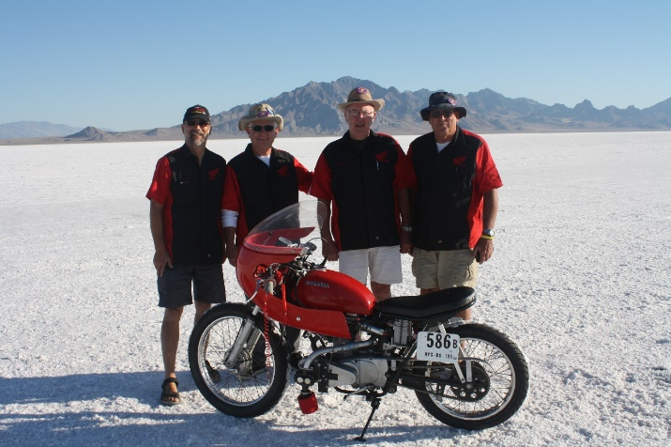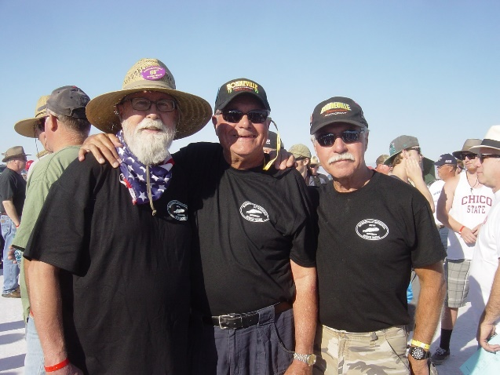
Bonneville Speed Week found members Jerry Pokorny, Mel Downs, Frank Puckett, George and Marsha Nachtsheim, Jim LeFebvre, Dana Robbins, Lenny Spall, Bruce Taylor, John Stoner, and John Thurston on the salt. Six records were taken and we are already excited about next year.
Also in August was our club picnic on Sunday, the 21st. John Stoner led the morning ride and it finished up at Frank Puckett’s house for a BBQ. We had a great turnout and fun was had by all. September I was out elk hunting, so I can’t fill you in on that. We were fortunate to have the Cannonball Coast to Coast race for pre 1917 motorcycles come through Pueblo in September. Jerry Pokorny organized a meal function for the riders. John Stoner photographed the bikes and riders and presented a slide show at our October meeting. In addition, Kris Geller rode with the Cannonball riders through Colorado and down into Utah and Arizona, and presented interesting tales of the adventure.
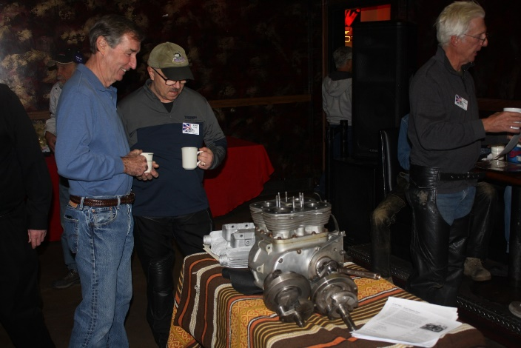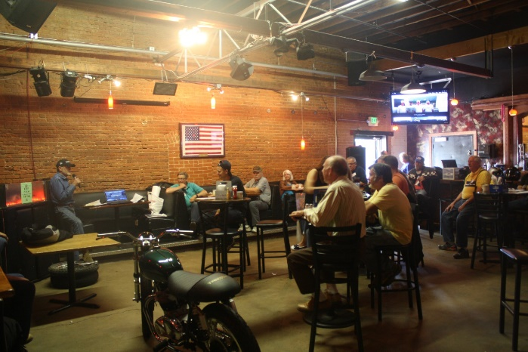
The November meeting gave us some great presentations. Hans Gross showed pictures and told of his ride and visit to the St. Francis Motorcycle museum in Kansas. We need to do a club ride there next year. Phil Johnston showed us an Ariel Square Four engine he is restoring and we enjoyed seeing what an interesting design it is. Todd Wallis showed tank and side cover paint jobs he has done for members, and also did a Tech Time on spoking and balancing wheels.
Thanks to all the members who helped with show and tell bikes, including bobbers, café racers, new Triumphs, old Triumphs, Nortons, and even Hondas and Puchs. A special thanks goes to Jerry Pokorny for keeping members informed, Jim LeFebvre for keeping the website going, and Robin Robbins for tracking our money and merchandise. John Stoner is always willing to put together a club ride and we thank him for that.
I guess it is not too early for New Year’s Resolutions. I am planning on continuing as president for one more year, and I resolve to take more pictures and do some newsletters through the year. My main goal will still be to have monthly meetings that are fun and informative. I will be looking to you, the members, to bring your talks and your knowledge to the meetings to help our newer members as they restore and enjoy their motorcycles. And bring a friend to the meeting, we need more members!!

Wrench, Ride Repeat!

Frank Puckett
President, 2016/1017

