British Motorcycle Association of Colorado
Summer Update

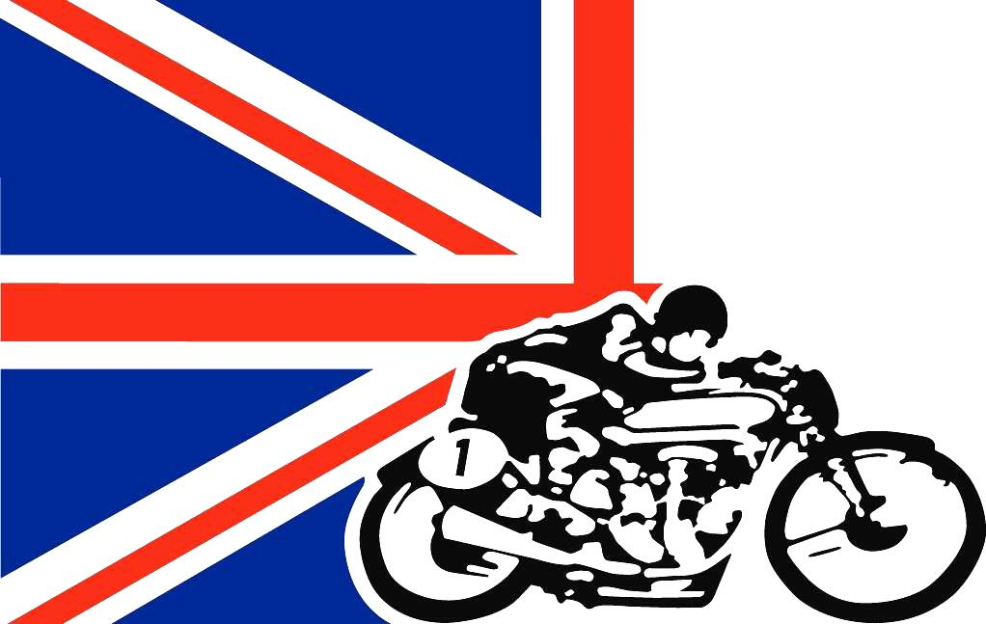

Our summer ride and BBQ were just completed Sunday, July 16th, so I guess that is a signal that summer is zipping by. We had our last meeting at Pikes Peak Harley-Davidson on June 24th. We welcomed new members and had a tech time on valve guide replacement and valve jobs on Triumph heads. Our next meeting is on Saturday, July 29th, at 10:00 am. We will be meeting at Pikes Peak Harley-Davidson in the upstairs motorcycle museum area, what a great venue! We will have two presentations on the great summer rides some of our members have had.
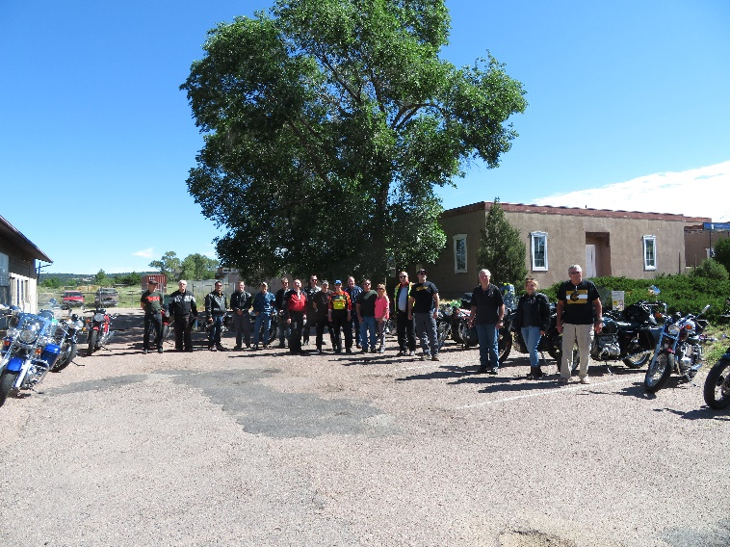
We welcomed new members Roger Zebill, Jesse Carraway, Andy MacDonald, Dale Quam, Joe Geanetta, Maria Gerber, James Baker, Phil Johnston, James Baker, and Scott Shuler since December!
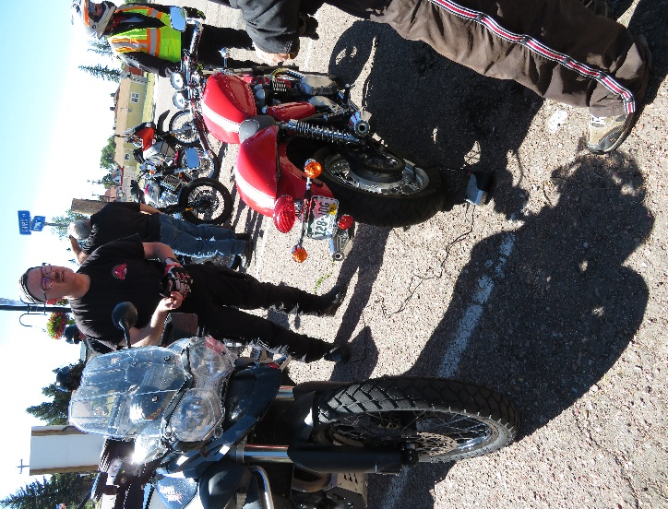
The summer ride and picnic was a rousing success, and thanks to all that participated. John Stoner led the morning ride from Monument to Sprucewood via Hiway 105 and Hiway 67. Seventeen bikes left Monument, and 4 more joined at Sedalia, so really a large turnout. Bob Wendl saved the day with his little 12 volt air pump. They don’t call him “Swiss Army Bob” for nothing, he and wife Denise are always prepared adventure bike team. All bikes made it home and the riders enjoyed some brand new pavement on Hiway 67.
The BBQ started after the ride and took place at Frank and Joanne’s house. We had a record 37 people come and enjoy the food and company, with perfect weather to boot. Please visit the website (bmacinc.com) to see many more pictures that webmaster Jim LeFebvre has posted.
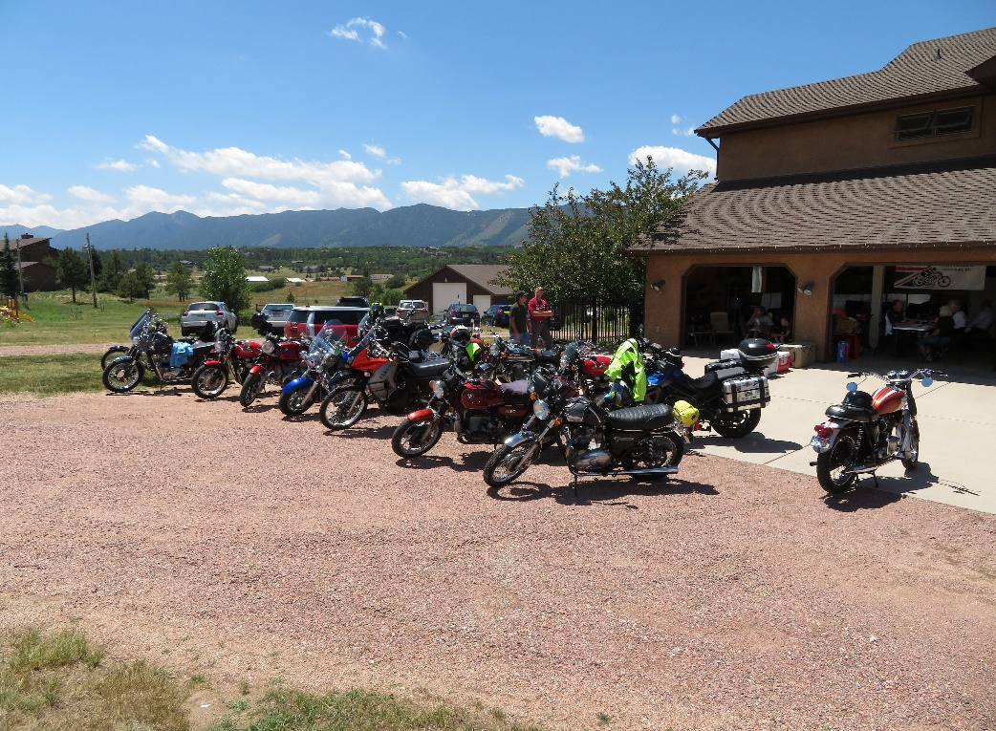

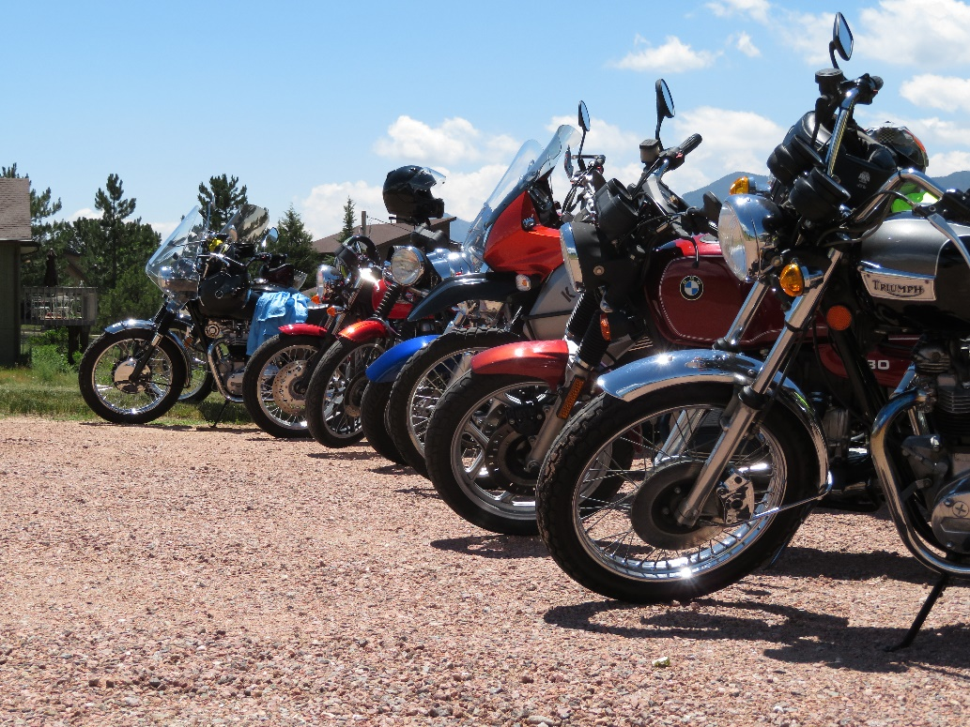

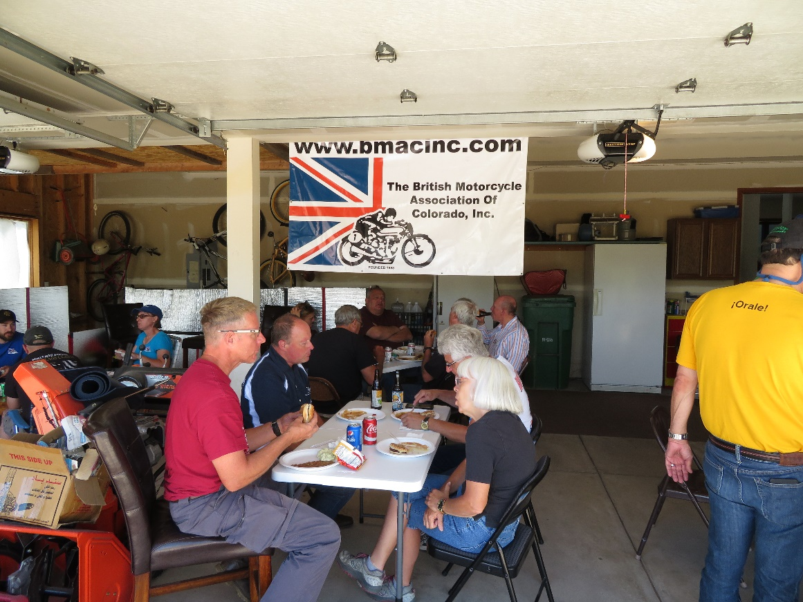
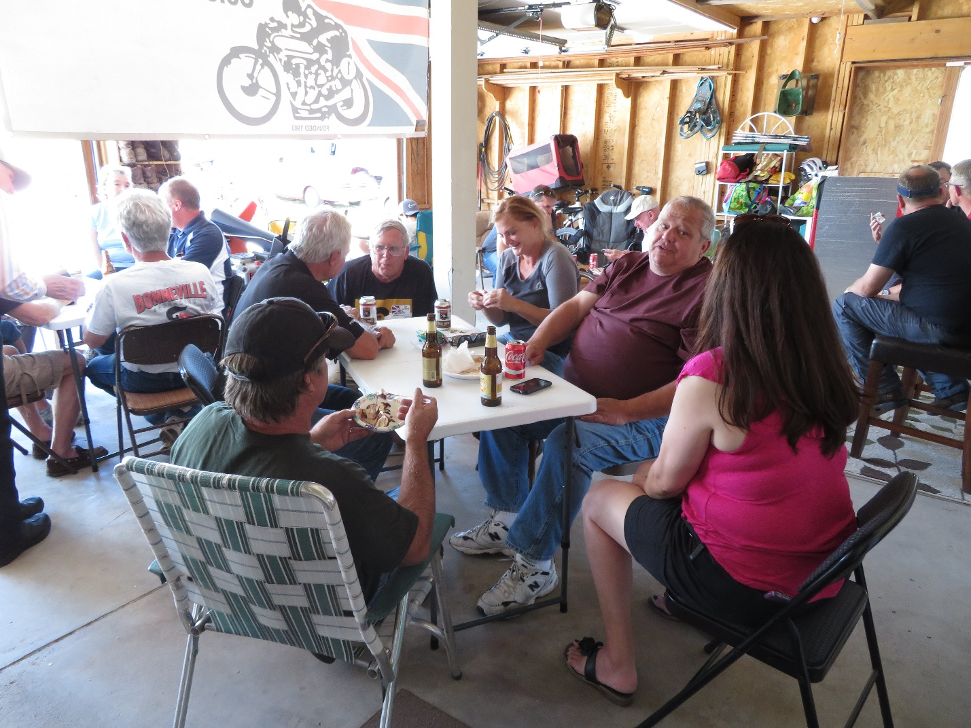

We have several members going to Bonneville Speedweek in August, so we are hoping for good salt and cooperative weather. And hopefully we will bring home some records! Several vintage Triumphs will be braving the salt flats looking for those land speed records.
Hope your summer is enjoyable and that you are able to get out on a motorcycle here and there. See you at the next meeting in July.
Frank Puckett, President.

